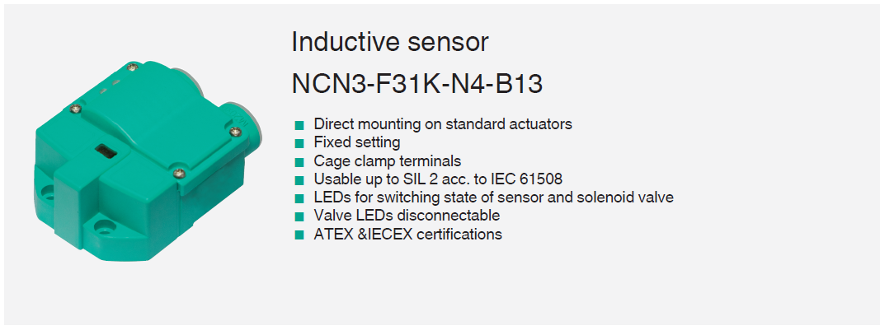Inductive sensor

NCN3-F31K-N4-B13

< Direct mounting on standard actuators

< Fixed setting

< Cage clamp terminals

< Usable up to SIL 2 acc. to IEC 61508

< LEDs for switching state of sensor and solenoid valve

< Valve LEDs disconnect able

< ATEX &IECEX certifications

**Dimensions**



65

5.4

40

35

9 5

14 11

9

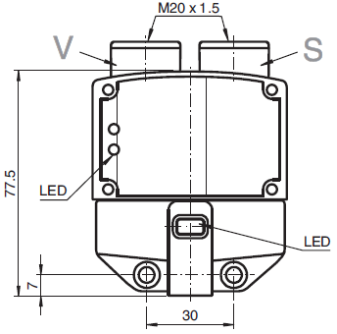M20 x 1.5

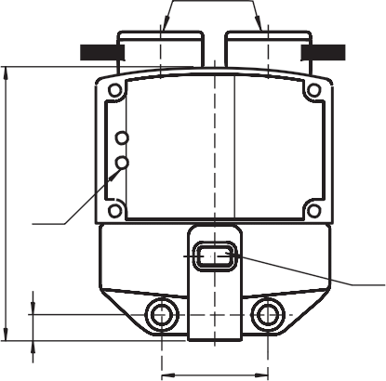

V S

LED

77.5

LED

30

7

**Technical Data**

|  |  |  |
| --- | --- | --- |
| **General specifications** | | |
| Switching function 2 x normally closed (NC) | | |
| Output type |  | NAMUR |
| Rated operating distance sn 3 mm | | |
| Installation |  | flush mountable |
| Assured operating distance sa 0 ... 2.4 mm | | |
| Actual operating distance | sr | 2.7 ... 3.3 mm typ. |
| Actuating element Stainless steel 1.4305 / AISI 303  8.5 mm x 8.5 mm x 0.5 mm | | |
| Reduction factor rAl |  | 0.5 |

Release date: 2025-07-03 Date of issue: 2025-07-03 Filename: 70110340_eng.pdf

**l Data**

Release date: 2025-07-03 Date of issue: 2025-07-03 Filename: 70110340_eng.pdf

|  |  |  |
| --- | --- | --- |
| Reduction factor rCu 0.4 | | |
| Reduction factor r304 |  | 1 |
| Reduction factor rSt37 1.3 | | |
| Reduction factor rBrass |  | 0.6 |
| Output type 2-wire | | |
| **Nominal ratings** | | |
| Nominal voltage Uo 8.2 V (Ri approx. 1 kΩ) | | |
| Switching frequency | f | 0 ... 3 kHz |
| Hysteresis H typ. 5 % | | |
| Reverse polarity protection |  | reverse polarity protected |
| Short-circuit protection yes | | |
| Suitable for 2:1 technology |  | yes , Reverse polarity protection diode not required |
| Current consumption | | |
| Measuring plate not detected |  | ≥ 3 mA |
| Measuring plate detected ≤ 1 mA | | |
| Time delay before availability | tv | ≤ 1.1 ms |
| Switching state indicator LED, yellow | | |
| Valve status indicator |  | LED, yellow |
| **Functional safety related parameters** | | |
| Safety Integrity Level (SIL) |  | SIL 2 |
| MTTFd 1470 a | | |
| Mission Time (TM) |  | 20 a |
| Diagnostic Coverage (DC) 0 % | | |
| **Valve circuit** | | |
| Voltage max. 32 V DC | | |
| Current |  | max. 240 mA |
| Short-circuit protection no | | |
| Reverse polarity protection |  | yes, with reversed output LED is out of function, therfore more power for solenoid valve |
| **Compliance with standards and directives** | | |
| Standard conformity |  |  |
| NAMUR EN 60947-5-6:2000  IEC 60947-5-6:1999 | | |
| Electromagnetic compatibility |  | NE 21:2007 |
| Standards EN IEC 60947-5-2 | | |
| **Approvals and certificates** | | |
| IECEx approval | | |
| Equipment protection level Ga |  | IECEx TUN 17.0021X |
| Equipment protection level Gb IECEx TUN 17.0021X | | |
| Equipment protection level Mb |  | IECEx TUN 17.0021X |
| ATEX approval | | |
| Equipment protection level Ga |  | TÜV 99 ATEX 1479 X |
| Equipment protection level Gb TÜV 99 ATEX 1479 X | | |
| Equipment protection level Gc (ic) |  | PF 13 CERT 2895 X |
| UL approval cULus Listed  Load Type: General Purpose Circuitry: Class 2 Power Source Enclosure Type Rating: Type 1  Supply/Switching Voltage: 8.2 V DC | | |
| Ordinary Location |  | E87056 |
| Hazardous Location E501628 | | |
| Control drawing |  | 116-0456 |
| CCC approval | | |
| Hazardous Location |  | 2020322315002262 |
| NEPSI approval | | |
| NEPSI certificate |  | GYJ19.1410X |

**Technical Data**

|  |  |  |
| --- | --- | --- |
| **Ambient conditions** | | |
| Ambient temperature |  | -25 ... 100 °C (-13 ... 212 °F) |
| Storage temperature -40 ... 100 °C (-40 ... 212 °F) | | |
| **Mechanical specifications** | | |
| Connection (system side) Cage tension spring terminals  Stripped length 7 mm  M20 x 1.5 cable gland  usable thread length 11.5 mm screw-in depth max. 11.5 mm | | |
| Core cross section (system side) |  | rigid: 0.14 ... 2.5 mm2  flexible: 0.14 ... 1.5 mm2  flexible with core-end sleeve: 0.25 ... 1.5 mm2 |
| Connection (valve side) like connection (system side) | | |
| Core cross section (valve side) |  | like core cross section (system side) |
| Housing material PBT | | |
| Sensing face |  | PBT |
| Degree of protection IP67 | | |
| Tightening torque, fastening screws |  | ≤ 5 Nm |
| Tightening torque, housing screws 1 Nm | | |
| Tightening torque, cable gland |  | M20 x 1.5 ; max. 7 Nm |
| Dimensions | | |
| Height |  | 35.5 mm |
| Width 65 mm | | |
| Length |  | 77.5 mm |
| Note LED switch-off | | |
| **General information** | | |
| Use in the hazardous area see instruction manuals | | |

**Connection Assignment**

4 L+

I

I II II

5

1

2

9/10

10/9

7/6

6/7

Release date: 2025-07-03 Date of issue: 2025-07-03 Filename: 70110340_eng.pdf

L− L+ L−

V+(V−) V− (V+) V− (V+)

V+(V−)

**Additional Information**

Interruption of LED:

In the case of a polarity reversal of the valve circuit connection/s, the valve status display does not function, i.e. such that low power valves can (also) be connected.